EXPERIMENT 10

TRIGGERS

**Aim:**

Create a table with attribute sname, and another table with newname.

Create a trigger to insert into second table before inserting in first table.

Create a table for account details with attributes account number and an amount.

Create a trigger to check if amount is negative or greater than zero before inserting to table.

**QURIES:**

Create a table with attribute sname, and another table with newname.



Create a trigger to insert into second table before inserting in first table.

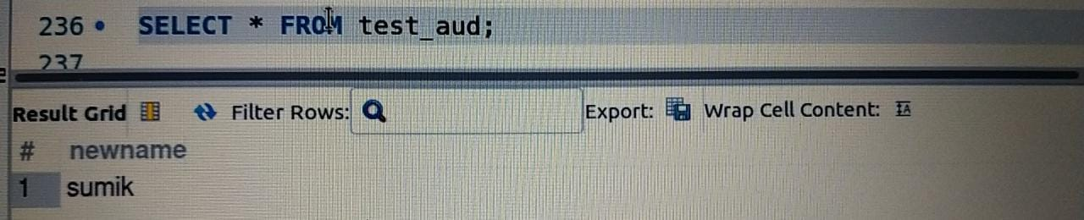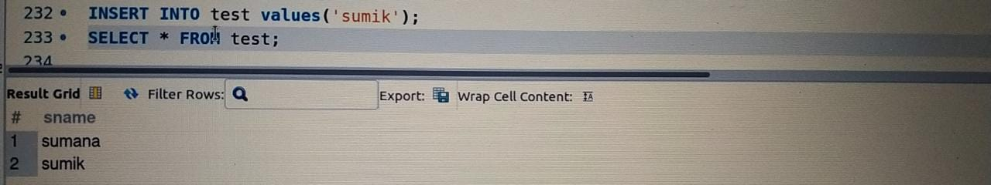

Create a table for account details with attributes account number and an amount.



Create a trigger to check if amount is negative or greater than zero before inserting to table.

